**STAT 40001/MA59800 Statistical Computing Fall 2017**

**Lab -17**

**Q.N. 1)** The more beer you drink, the more your blood alcohol level (BAL) rises. Table below contains a data set on beer consumption.

Beers 5 2 9 8 3 7 3 5 3 5

BAL 0.10 0.03 0.19 0.12 0.04 0.095 0.07 0.06 0.02 0.05

1. Make a scatterplot with a regression line

> Beers = scan()

1: 5 2 9 8 3 7 3 5 3 5

11:

Read 10 items

> BAL = scan()

1: 0.10 0.03 0.19 0.12 0.04 0.095 0.07 0.06 0.02 0.05

11:

Read 10 items

> plot(Beers,BAL)

> model = lm(BAL~Beers)

> abline(model)

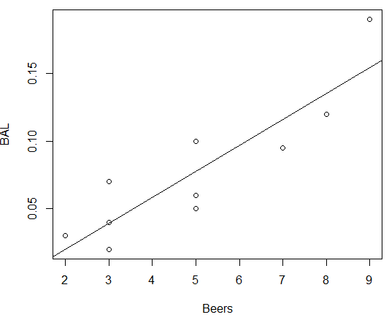

1. Calculate 95% confidence interval for the model parameters

> confint(model)

2.5 % 97.5 %

(Intercept) -0.06284414 0.02584414

Beers 0.01110391 0.02729609

1. State the estimated linear regression model.

> model

Call:

lm(formula = BAL ~ Beers)

Coefficients:

(Intercept) Beers

-0.0185 0.0192

BAL_hat = -0.0185 + 0.0192*Beers

**Q.N. 2)** A marketing researcher studied annual sales of a product that had been introduced 10 years ago. The data are as follows, where x is the year coded and y is the sales in thousands of units:

x: 0 1 2 3 4 5 6 7 8 9

y: 98 135 162 178 221 232 283 300 374 395

1. Prepare a scatter plot of the data

> x = scan()

1: 0 1 2 3 4 5 6 7 8 9

11:

Read 10 items

> y = scan()

1: 98 135 162 178 221 232 283 300 374 395

11:

Read 10 items

1. State the estimated regression line for the data and add it to the scatter plot.

> plot(x,y)

> plot(x,y)

> model = lm(y~x)

> abline(model)

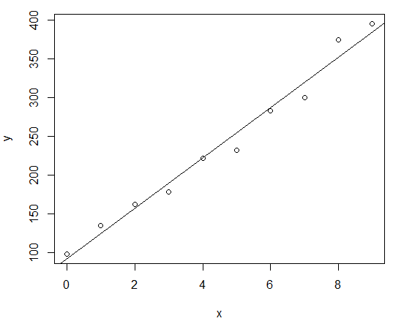

> model

Call:

lm(formula = y ~ x)

Coefficients:

(Intercept) x

91.56 32.50

Yhat = 91.56 + 32.5 * x

d) Use the model to predict the sales in the 10th year (i.e. For x=10). Also provide the 95% and 90% confidence interval for the predicted value.

> predict(model,data.frame(x=10),level = 0.9,interval = 'conf')

fit lwr upr

1 416.5333 397.4827 435.5839

> predict(model,data.frame(x=10),level = 0.95,interval = 'conf')

fit lwr upr

1 416.5333 392.9089 440.1578

**Q.N. 3)** A simple random sample of apparently healthy children between the ages of 6 months and 15 years yielded the following data on age, X, and liver volume per unit of body weight (ml/kg), Y

|  |  |  |  |  |  |  |  |  |  |  |  |  |  |  |  |
| --- | --- | --- | --- | --- | --- | --- | --- | --- | --- | --- | --- | --- | --- | --- | --- |
| X | 0.5 | 0.7 | 2.5 | 4.1 | 5.9 | 6.1 | 7 | 8.2 | 10 | 10.1 | 10.9 | 11.5 | 12.1 | 14.1 | 15 |
| Y | 41 | 55 | 41 | 39 | 50 | 32 | 41 | 42 | 26 | 35 | 25 | 31 | 31 | 29 | 23 |

1. Prepare a scatter plot of the data

> x = scan()

1: 0.5 0.7 2.5 4.1 5.9 6.1 7 8.2 10 10.1 10.9 11.5 12.1 14.1 15

16:

Read 15 items

> y = scan()

1: 41 55 41 39 50 32 41 42 26 35 25 31 31 29 23

16:

Read 15 items

1. State the estimated regression line for the data and add it to the scatter plot.

> model = lm(y~x)

> plot(x,y)

> abline(model)

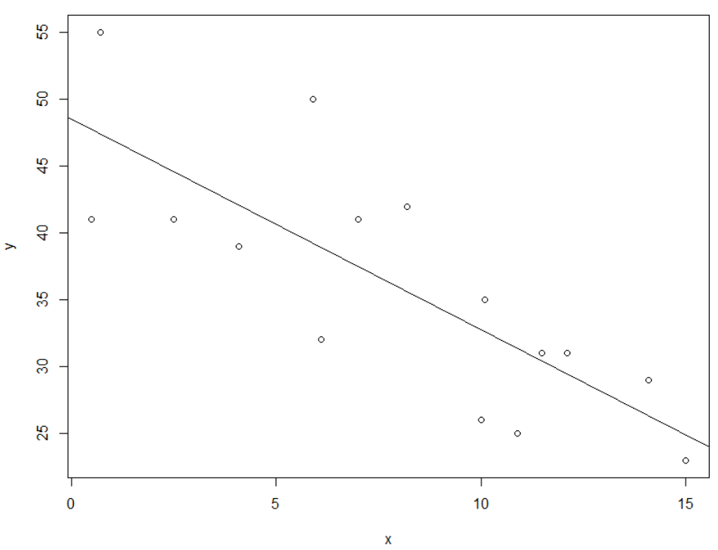

1. Use the model to predict the liver volume of 8 years old child.

> predict(model,data.frame(x=6))

1

39.08246

e) Construct a 90% Confidence interval for the predicted value of the liver volume of 8 years old child

> predict(model,data.frame(x=6),level = 0.9,interval = 'conf')

fit lwr upr

1 39.08246 36.1616 42.00332

f) Construct a 90% prediction interval for the predicted value of the liver volume of 8 years old child

> predict(model,data.frame(x=6),level = 0.9,interval = 'pred')

fit lwr upr

1 39.08246 28.2899 49.87501